3-Dimensional Position From Trinary 3-D Integration Of Div, Grad, & Curl According To The Free World Alliance By Dr. AllA Viacad
$$\overset{⃑}{i}=x, \overset{⃑}{j}=y,\overset{⃑}{k}=z Directional Unit Vecors$$
$${\overset{⃑}{Force}=F}_{\overset{⃑}{i}}\overset{⃑}{i}+F_{\overset{⃑}{j}}\overset{⃑}{j}+F_{\overset{⃑}{k}}\overset{⃑}{k}=\left\langle F_{\overset{⃑}{i}},F_{\overset{⃑}{j}},\right.\left.F_{\overset{⃑}{k}}\right\rangle =mass*\overset{⃑}{accelertion}=m*\overset{⃑}{a}=m\overset{⃑}{a}$$
$$Gradient=∇=\frac{∂}{∂x}\overset{⃑}{i}+\frac{∂}{∂y}\overset{⃑}{j}+\frac{∂}{∂z}\overset{⃑}{k}=\left\langle \frac{∂}{∂x},\frac{∂}{∂y}\right.,\left.\frac{∂}{∂z}\right\rangle =Rate of Change In 3D ↔\iiint{∇}d\overset{⃑}{a}=\iint{∇d\overset{⃑}{v}}=\int{∇}d\overset{⃑}{position}=\left(x,y,z\right)$$
$$Div=∇∙\overset{⃑}{F}=\frac{∂F_{\overset{⃑}{i}}}{∂x}+\frac{∂F_{\overset{⃑}{j}}}{∂y}+\frac{∂F_{\overset{⃑}{k}}}{∂z}=Rate Of Change of Force Applied Which Changes \overset{⃑}{a} From Above$$
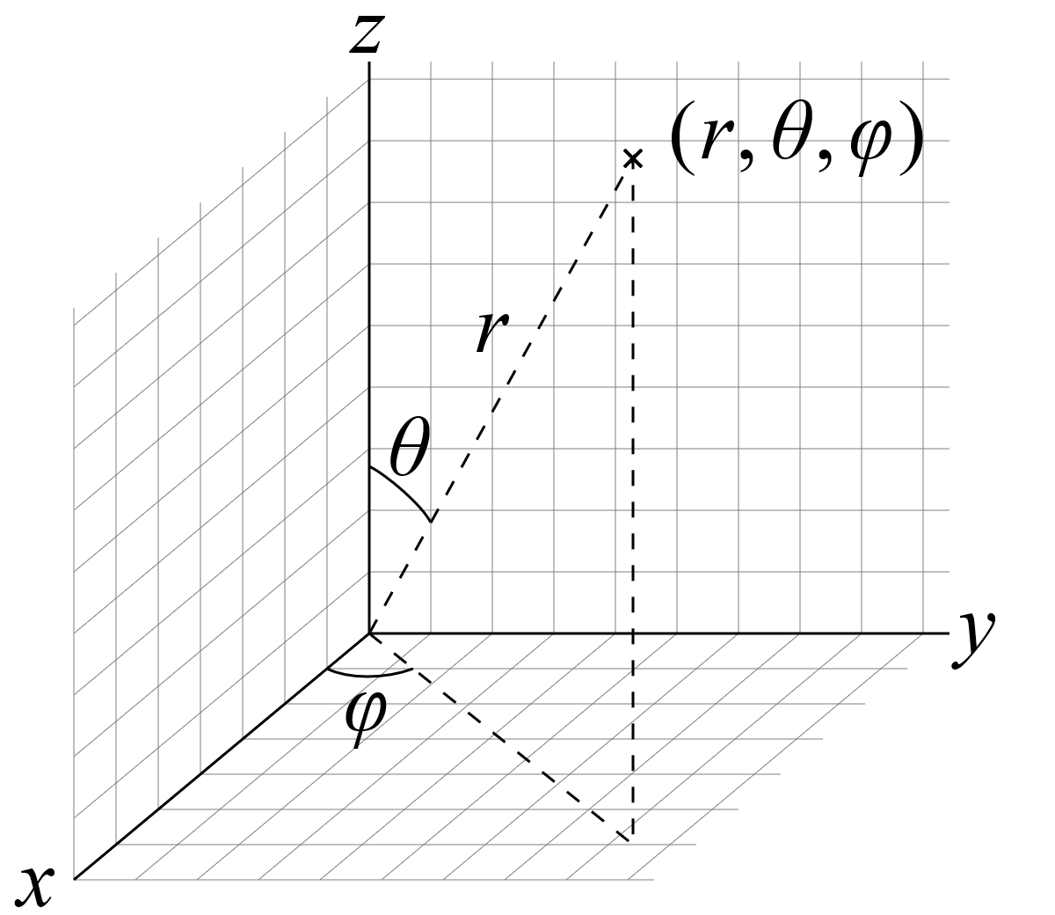
$$Curl=∇×\overset{⃑}{F}=\left|\begin{matrix}\overset{⃑}{i} \\ \frac{∂}{∂x} \\ F_{\overset{⃑}{i}}\end{matrix} \begin{matrix}\overset{⃑}{j} \\ \frac{∂}{∂y} \\ F_{\overset{⃑}{j}}\end{matrix} \begin{matrix}\overset{⃑}{k} \\ \frac{∂}{∂z} \\ F_{\overset{⃑}{k}}\end{matrix}\right|=\frac{∂\overset{⃑}{F}\sin\left(θ\right)\cos\left(φ\right)\overset{⃑}{i}}{∂x}+\frac{∂\overset{⃑}{F}\sin\left(θ\right)\sin\left(φ\right)\overset{⃑}{j}}{∂y}+\frac{∂\overset{⃑}{F}\cos\left(θ\right)\overset{⃑}{k}}{∂z}=Rate Of Change of Rotation Of Force Causeing Centripetal Velocity From$$
$${\overset{⃑}{a}}_{c}=\frac{v^{2}}{\overset{⃑}{r}} \left|\overset{⃑}{r}⇐\frac{\overset{⃑}{F}}{m}\right. Inducing Divergence Of Trajectory Of NonInertially Dampened Movement$$Which If Integrated Over All Div For 1 Dimension Provides Linear Acceleration Felt Equal & Opposite If UnDampened, If There Is Change In Rotation Of Force Felt As ${\overset{⃑}{a}}_{c}$ If UnDampened. Integration Of Curl Provides Acceleration In 3D. Integration Of $\overset{⃑}{Acceleration}$ Provides $\overset{⃑}{Velocity}$. Integration Of $\overset{⃑}{Velocity}$ Position (x,y,z).
$$\iiint_{time=beginning}^{time=end}{\overline{Div} (dt)}=\iint_{time=beginning}^{time=end}{m\vec{a} dt}=\int_{time=beginning}^{time=end}{\vec{v}}dt=\left(x,y,z\right)=\left( r*sin\left(θ\right)\cos\left(φ\right),r*sin\left(θ\right)\sin\left(φ\right),r*cos\left(φ\right) \right)$$
$$∰_{t=beginning}^{t=end}{\hat{Curl} (dt)}=∯_{t=beginning}^{t=end}{m\overset{⃑}{a} dt}=\oint_{t=beginning}^{t=end}{\overset{⃑}{v} dt}=\left(x,y,z\right)=\left( r*sin\left(θ\right)\cos\left(φ\right),r*sin\left(θ\right)\sin\left(φ\right),r*cos\left(φ\right) \right)$$

